<https://youtu.be/sFECyq1ygTw>

<https://github.com/aputex/CUT-THE-LOOP>

Climate Changer

**why nasa**

Greetings from climate changer! Welcome to the project “Cut the loop”

In this session we are trying to solve the category ***Living In Our World*** sub category :**Warming Planet, Cool Ideas”** which demand the improvement of the Earth weather and/or ***eliminate processes*** that cause global warming. Your solution could be a technology, a movement, an idea

In our project “Cut the loop” instead of burning fuel (which produce CO2) to run the boiler to make electricity or to generate steam in many industry we will use solar energy to run the boiler . By commercializing our technological idea a mass amount of C02 will not produce hence a vast amount of green house gas will reduce as a result global warming will decline.

As our idea is a a technology as well as a movement , eliminating a process that casus global warming, so can confidently say that our project is a preface match for this sub category .

**Short**

In our solution instead of burning fuel (which produce CO2) to run the boiler to make electricity or to generate steam in many industry we will use solar energy to run the boiler

A blast of sun energy came to an parabolic mirror and then focused on a single point THAT GENERATE 550 DEGREE CELCIUS TEMPERATURE of a boiler which convert the water into stem by which we can make electricity from a generator by rotating its turbine

Initially this solution along can not fully replace the gas burning method But it can minimize the production of CO2 by producing maximum steam required by a industry , we must take this movement for commercializing our technological idea

As our project meet the main 3 criteria by having

1.an idea

2.a technology

3. a movement

And eliminate a a process that casus global warming, so can confidently say that our project must achieve a award of galactic impact or Best Use of Hardware or Best use of Science.

Broad

Greetings from climate changer! Welcome to the project “Cut the loop”

In this year 2019 we are trying to solve the category ***Living In Our World*** sub category :**Warming Planet, Cool Ideas”** which demand the improvement of the Earth weather and/or ***eliminate processes*** that cause global warming. Your solution could be a technology, a movement, an idea

Humans have increased atmospheric CO2 concentration by more than a third since the Industrial Revolution began. This is the most important long-lived "forcing" of climate change[<https://climate.nasa.gov/causes/>]

A stronger greenhouse effect will warm the oceans and partially melt glaciers and other ice, increasing sea level. Ocean water also will expand if it warms, contributing further to sea level rise. [<https://climate.nasa.gov/causes/>]

So now as we know from NASA CO2 is one of the main reason for global warming so our project is to design a process that eliminate the burning of fuel that produce CO2

In our solution instead of burning fuel (which produce CO2) to run the boiler to make electricity or to generate steam in many industry we will use solar energy to run the boiler

A blast of sun energy came to an parabolic mirror and then focused on a single point THAT GENERATE 550 DEGREE CELCIUS TEMPERATURE of a boiler which convert the water into stem by which we can make electricity from a generator by rotating its turbine

Initially this solution along can not fully replace the gas burning method But it can minimize the production of CO2 by producing maximum steam required by a industry , we must take this movement for commercializing our technological idea

From a rough calculation we can get

from a solar plant having 73 parabolic mirror (16 square meter ) we can get 3.5 ton stem per day that means 1277.5 ton stem per year. Without burning a single amount of gas

so by adopting this solution we can minimize a huge amount of Carbon di-oxide production

As our project meet the main 3 criteria by having

1.an idea

2.a technology

3. a movement

And eliminate a process that casus global warming, so can confidently say that our project must achieve a award of galactic impact or Best Use of Hardware or Best use of Science.

In future

1. we will increase the efficiency of this product so that it can replace boiler
2. we will use it in other industry like food industry
3. we will use it as our heat reservoir
4. we will redesign it to use it in out household work

5 benefits

1. it will reduce global warming
2. in this era of global warming it can be easily commercialized
3. it is sustainable
4. from its by product we can get pure water
5. it is cost effective as no fuel is needed

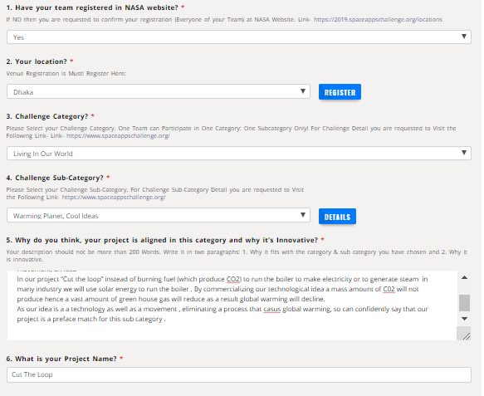

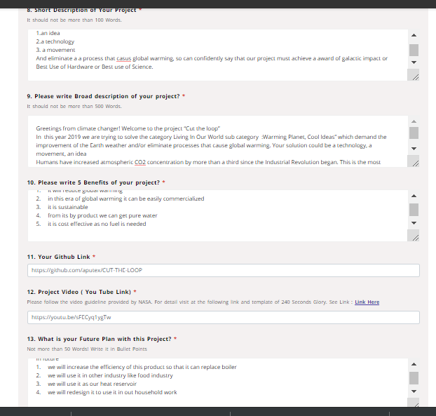

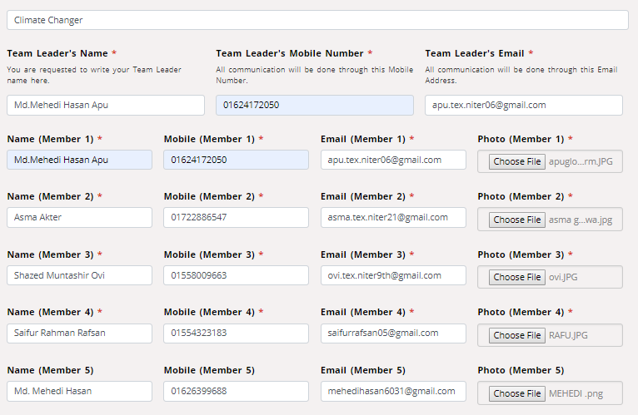

Md.Mehedi Hasan Apu

01624172050

[apu.tex.niter06@gmail.com](mailto:apu.tex.niter06@gmail.com)

Asma Akter

01722886547

[asma.tex.niter21@gmail.com](mailto:asma.tex.niter21@gmail.com)

Shazed Muntashir Ovi

[ovi.tex.niter9th@gmail.com](mailto:ovi.tex.niter9th@gmail.com)

/CC

01558009663 /CC

Saifur Rahman Rafsan

[saifurrafsan05@gmail.com](mailto:saifurrafsan05@gmail.com)

/CC

01554323183

Name: Md. Mehedi Hasan

Mobile No: 01626399688

E- mail: mehedihasan6031@gmail.com